**Seat/Client Assignment First Pass**

**Overview**

The purpose of the first pass of the project is to create an application that allows assigning the clients to a seating matrix. The clients are booked to vacant seats. In the first pass of the project, clients are randomly assigned to a 10x10 matrix instead of manual assignment. Hence, there’s no user interaction in the first pass.

**Core Features**

* Contain a list of clients.
* Contain an internal matrix that is originally not assigned.
* Assign clients to seats randomly.
* Display the matrix with seating arrangement
* Display a list of clients and their seating assignment.

**Constraints**

* Limited amount of time for the delivery of the Project.

**Background**

The core purpose of this app is to assign a list of clients to a matrix that is initially unassigned. The clients are assigned to random spots in the matrix.

Several classes are created for the implementation.

* The Client Class
* The ClientStore Class
* The RoomMatrix Class
* The Seat Class

The Client Class holds the last name, first name, and IDs of the clients. The ClientStore Class loads the clients from excel, and stores the clients in an array of type Client. The list of clients are printed in console after loading from the csv file, shown in **Figure.1**.

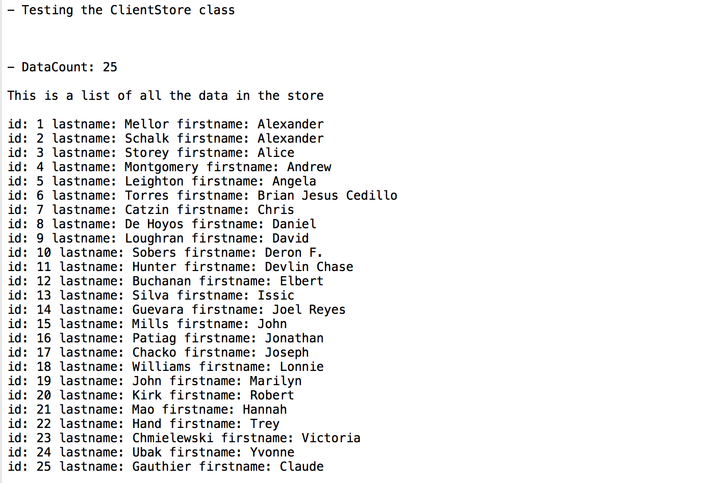

**Figure 1 List of Clients**

The Seat Class holds the names and the IDs of the client assigned. In addition, the Seat Class also holds the row and column index of the seat that the particular client is assigned to. The RoomMatrix Class prints the 10 x 10 matrix to the console with the list of clients randomly assigned, as shown in **Figure.2**.

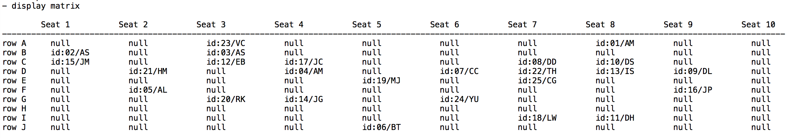

**Figure 2 Display of matrix with seating assignment**

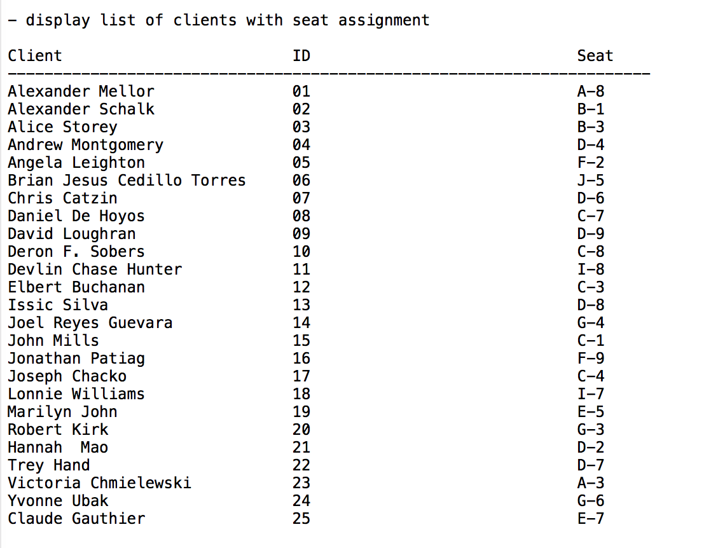The RoomMatrix Class also prints a list of clients with seating assignment, as shown in **Figure.3**.

**Figure 3 Display of Clients with Seating Assignment**

**Conclusion**

This project really refreshed my skill in writing in Object Oriented Programing. Especially by creating the Client class that serves as an entity to hold the basic information about each client. In another word, information about each client is encapsulated in the Client Class, and the Client Class has methods that can be used to manipulate the information. In addition, this project also allows me to get comfortable with working with 2D array, especially with printing and formatting of the 2D array.

Overall it sets the path that leads to the 2nd pass of the project, which will involve user assignment of a client to a seat similar to booking system for a movie theatre.